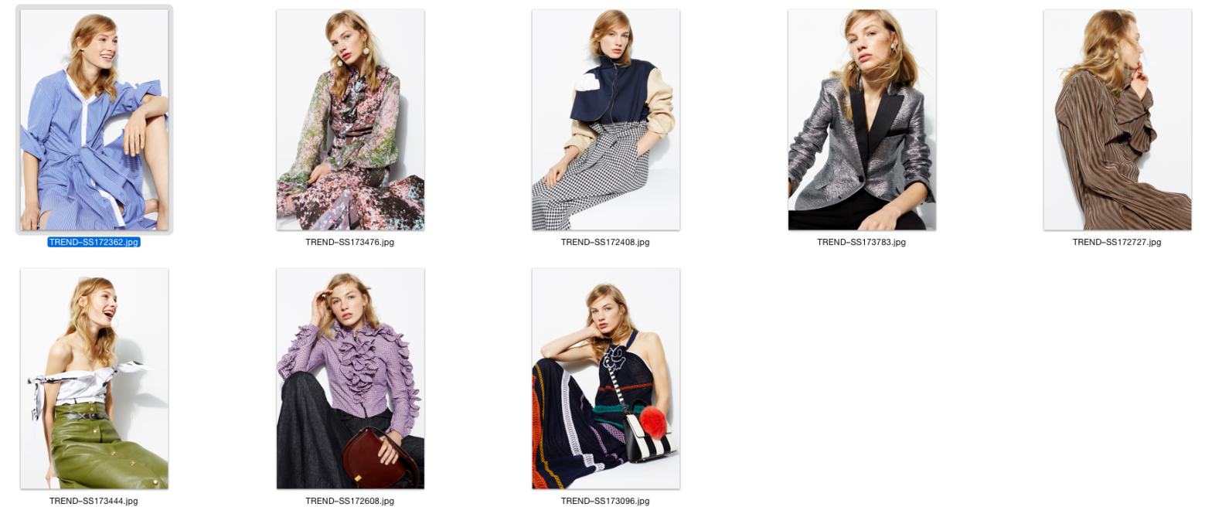

1- SHIRTS DECONSTRUCTED

The button-up blouse has been taken apart and creatively restructured this season. Expect knots, frills and clever cut-outs.

2- MICRO FLORALS

Spring 17’s microscopic florals are the vivid pops of colour giving flirty dresses and sharp outerwear a new lease of life.

3- THE TRENCH COAT 3.0

Trans-seasonal with tomboyish allure, the timeless trench coat gains fresh textiles and progressive proportions to cater for every taste.

4− MAGIC METALLICS

Twinkle around the clock as pastel and paintbox shades join glitter and sequins on this season’s shine spectrum.

5− PLEATS OR PLISSÉ?

Why decide when both fabric folds have been deployed to such wonderful, figure-skimming effect from top to bottom?

6− THE SHOULDER SHOW

From off-the-shoulder to completely strapless, clean or decorative- widespread neckline and sleeve experimentation delivers dazzling results.

7 − RUFFLES REINVENTED

Ruffles unveil a cooler, sexier new demeanour this season with unusual fabrications and assorted dimensions. Streamline accompanying styles.

8 − READY, SET, STRIPE!

The minimal perennial pattern often foils more elaborate motifs but not for SS17. Go bold or go home.